Bio-data of Supervisor / Co-Supervisor
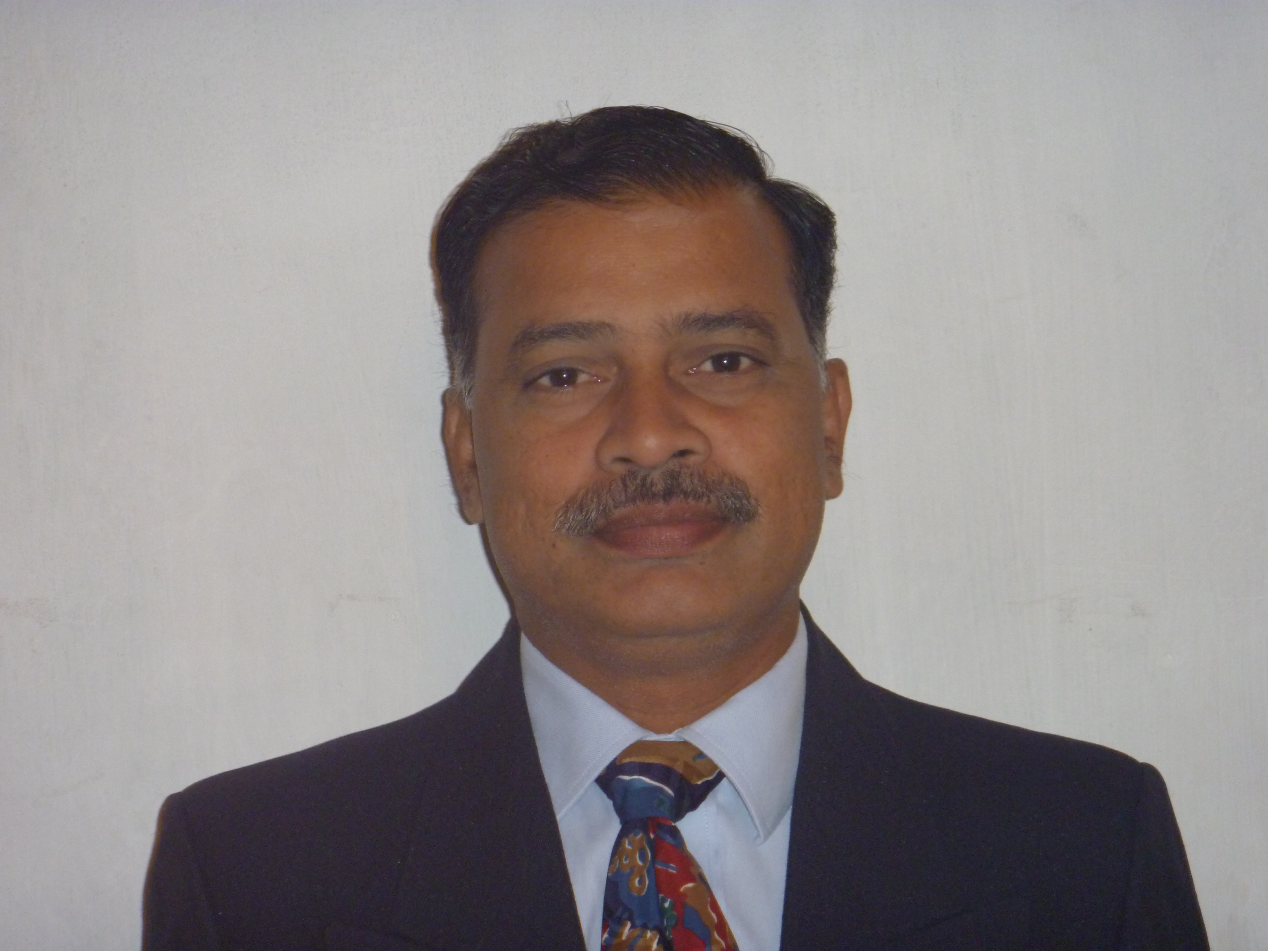

- Name : Dr. Chintu Janardhana Rao

- Address with E-mail, : raoj_chintu@yahoo.com
Land line and Mobile Nos. : 9494587285, 9440416577

Official Address : AITAM, Tekkali, Srikakulam Dist.

Permanent Address : Koyyana Vari Thota, Near Sai ITI, Arasavilli, Srikakulam – 532 401. A. P.

- Nationality : Indian
- Religion : Hindu

- Date of Birth : 05-01-1966

- Educational Qualification : Ph. D
(from UG onwards)
S. No. | Qualification | University/Institute | Specialization | Department | Other remarks
1 | A.M.I.E. | I.E.(India) | Mechanical Eng. | Mechanical Eng. | ----
2 | M.E. | M.S.U. of Baroda | Production | Mechanical Eng. | ----
3 | Ph. D. | AU, Vishakapatnam | Mechanical Eng. | Mechanical Eng. | ----

- Details of Doctoral Thesis : MECHANICAL ENGINERING

Area of Thesis work : Manufacturing

Title of Thesis : “STUDY ON APPLICABILITY OF MODULARITY IN MANUFACTURING INDUSTRY”

Supervisor : Dr. D. Nageswara Rao

Year of Completion work : 2011

Year of award of Ph. D : 29-05-2012

- Professional Experience :
S. No. | Institute / Organization | Position held | Date of joining | Duration |  | Regular/ Adhoc /Ratified
1 | AITAM, Tekkali | Professor & Controller of Examinations | 08-09-2004 | Nov 2013 | Till Date | Regular
2 | AITAM, Tekkali | Professor | 08-09-2004 | Jan 2012 | Oct 2013 | Regular
3 | AITAM, Tekkali | Professor & Head | 08-09-2004 | Jul 2009 | Dec 2011 | Regular
4 | AITAM, Tekkali | Assoc. Prof. & Head | 08-09-2004 | Sep 2006 | Jun 2009 | Regular
5 | AITAM, Tekkali | Sr. Asst.Prof. & Head | 08-09-2004 | Mar 2006 | Oct 2006 | Regular
6 | AITAM, Tekkali | Sr. Asst. Prof. | 08-09-2004 | Nov 2005 | Feb 2006 | Regular
7 | AITAM, Tekkali | Asst. Prof. | 08-09-2004 | Sep 2004 | Oct 2005 | Regular
8 | JITM, Parlakhemundi, Odisha | Lecturer | 05-09-2001 | Sep 2001 | Aug 2004 | Regular
9 | Edla Infotech Ltd., Hyderabad | Software Engineer | 15-05-2000 | May2000 | Sep 2001 | Regular
10 | Engineers India Ltd., New Delhi | Sr. Mech. Engineer | 03-01-1997 | Jan 1997 | Apr 2000 | Adhoc
11 | ESSAR Projects Ltd., Visakhapatnam | Jr. Engineer | 02-03-1994 | Mar 1994 | Nov 1996 | Regular
12 | The Calcutta Shipping & Marine Engg. Co. (P) Ltd., Visakhapatnam | Engineer | 02-05-1992 | May1992 | Feb 1994 | Regular

- Research projects completed as Coordinator :

S. No. | Title of the Project | Funding agency | Sanctioned amount and Year of Sanction | Duration of the project | Present status
-- | -- | -- | -- | -- | --

Research Experience :
- Ph.D. scholars guided :

S. No. | Name of the Research Scholar | Title of the Thesis | Year of Award of Ph.D | University /Institute who has awarded the degree | Supervisor/  Co-Supervisor
-- | -- | -- | -- | -- | --

- Ph. D. scholars presently working :
S. No. | Name of the Research Scholar | Area of the work | Year of Registration | Registered  University /Institute | Supervisor/  Co-Supervisor
-- | -- | -- | -- | -- | --

(C) Number of Publications :

S. No. | Status of Journal | During Ph.D programme | After Ph.D programme
1 | International Journals | 2 | 2
2 | National Journals | -- | --
3 | International Conferences | -- | 1
4 | National Conferences | 1 | --

List of Publications :

International Journals : 04

S. No. | Authors | Title of the Research paper | Name of the Journal | Volume No. | Issue No. | Page Nos. | Year of publication | Impact factor
1 | C. J. Rao, D. Nageswara Rao and D. S. Sudheer | Modular Manufacturing | International Journal of Mechanical Engineering | 2 | 2 | 81 to 83 | 2009 | --
2 | C. J. Rao, D. Nageswara Rao and V. Sai Srikanth | Performance of single modular manufacturing unit with queuing model based material handling system using AGVS | International Journal of Engineering Science and Technology | 2 | 5 | 929 to 941 | 2010
3 | P. Srihari, D. Azad and Dr. C. J. Rao | Stress analysis of Embedded Rail Insert in Prestressed Concrete Sleeper | International Journal of Engineering Research & Technology | 2 | 10 |  | 2013 | --
4 | G.V.Srinivasa Rao, Dr. C. J. Rao and Dr. N. Haribabu | Heat Transfer Analysis on Shell and Tube Heat Exchangers | International Journal of Research in Aeronautical and Mechanical Engineering IJRAME | 2 | 1 | 11 to 26 | 2014 | --

National Journals : Nil
S. No. | Authors | Title of the Research paper | Name of the Journal | Volume No. | Issue No. | Page Nos. | Year of publication
-- | -- | -- | -- | -- | -- | -- | --

International Conferences: 01

S. No. | Authors | Title of the Research paper | Name of the Proceedings | Page Nos. | Dates of the conference. | Organized by
1 | Dr. C. J. Rao, Dr. D. Nageswara Rao and P. Srihari | Influence of cutting parameters on cutting force and surface finish in turning operation | Procedia Engineering | 1405-1415 | 18-20 July 2013 | IIITD&M, Kancheepuram

National Conferences: 01
S. No. | Authors | Title of the Research paper | Name of the Proceedings | Page Nos. | Dates of the conference. | Organized by
1 | V. Sai Srikanth, Dr. D. Nageswara Rao and C. J. Rao | A non-linear programming approach for the utilization of AGVs in Modular Manufacturing | 23rd National Convention of Mechanical engineers |  | 10-12 September 2007 | Institute of Engineers (India), Engineers India Bhavan, Hyderabad

(E) Patents Applied
:
S. No. | Title of the Patent | Agency to which application is made | Year of application
-- | -- | -- | --

(F) Patents Received
:
S. No. | Title of the Patent | Agency which has awarded the patent | Year
-- | -- | -- | --

- Areas of research interests : Production Technology
Machine Tools
Unconventional Machining Processes
Metrology
Modern Manufacturing Methods

- Awards : --

- Text Books authored : --

- Membership in Professional organizations : ISTE, ASME, FIE

- Other information (if any) : Controller of Examinations

Declaration

I hereby declare that the information furnished is true to the best of my knowledge and belief.

Signature

(Ch. Janardhana Rao)

Date: 20-09-2014

Station: Tekkali.

Format of the Joining report

To
The Director (R & D)
JNT University, Kakinada
Kakinada

Dear Sir,

Sub:- Joining Report ---Reg.
Ref: Admission Letter issued by the Directorate of Admissions dated__________________

I hereby join in PhD Programme in _________________________Discipline as per your Admission letter cited. I hereby submit the following documents .

1. Self-declaration forms of Supervisor & Co-Supervisor

2. Bio-data of supervisor & Co-Supervisor in the prescribed format
(Not required for faculty members working in JNT University,
Kakinada)

3. Xerox copy of Ph.D degree certificate of Supervisor & Co-Supervisor

4. Joining report of the candidate signed by Supervisor & Co-Supervisor
in the prescribed format

5. Pending documents to be submitted at the time of admission

6. Photo copy of Adhar card / PAN card / Passport of Supervisor & Co-Supervisor,
if they are external to the JNT University, Kakinada (To verify the signature of
the supervisor & Co-supervisor to streamline process)

7. Pending documents (if any), which are not submitted in Directorate (Admissions)
(List them)

The area of the work is finalized as …………………… ………………………………and the

topic is ………………………………………………………….

Yours faithfully,

(Signature of the candidate
and temporary and permanent address
with mobile No. and E-mail)
Supervisor Signature with seal

Co-Supervisor Signature with seal

