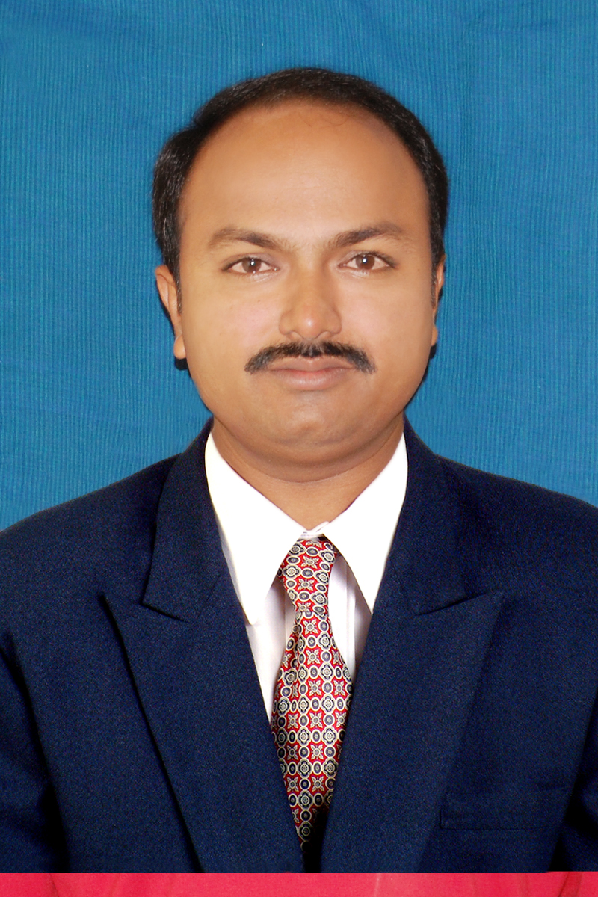
Bio-data of Supervisor /Co-Supervisor

- Name : Dr. B. V. Ramana

- Address:
E-mail : ramana.bendi@gmail.com
Land line and Mobile Nos. : 9441053733

Official Address : Prof & HOD, Department of IT,
Aditya Institute of Tech & Magt,
Tekkali-532201,Srikakulam (dt).

Permanent Address : s/o Bendi Ramulu, D.No: 2-135,
Venkateswara Colony, Tekkali,
Srikakulam (dt)-532201.

- Nationality : Indian
- Religion : Hindu

- Date of Birth : 04-JUNE-1976

- Educational Qualification :
(from UG onwards)

S. No. | Qualification | University/Institute | Specialization | Department | Other remarks
1 | B. Tech | N.U, Guntur | Mechanical | Mechanical | FIRST class with distinction
2 | M. Tech | JNTUH, Kakinada | Computer Science & Engg | Computer Science & Engg | FIRST class with distinction
3 | Ph.D | Andhra University | Data Mining | CS&SE | -

- Details of Doctoral Thesis :
Area of Thesis work : Classification Algorithms
Title of Thesis : A CRITICAL STUDY OF CLASSIFICATION ALGORITHMS FOR
AUTOMATIC DIAGNOSIS OF LIVER DISEASES: A CASE STUDY ON INDIAN HEPATOBILIARY DATA.

Supervisor : Prof. M. S. Prasad Babu
Year of Completion work : 2012
Year of award of Ph.D : 2014
- Professional Experience :
S. No. | Institute / Organization | Position held | Date of Joining | Duration | Regular/ Adhoc /Ratified
1 | AITAM, Tekkali | Assoc. Prof. | 01-11-07 | 6 Year 5 months | Regular
2 | AITAM, Tekkali | Asst. Prof. | 18-03-05 | 2 Year 7 months | Regular
3 | JITM, Parlakhemundi | Asst. Prof. | 04-10-02 | 2 Year 5 months | Regular

- Research projects completed as Coordinator :
S. No. | Title of the Project | Funding agency | Sanctioned amount and Year of Sanction | Duration of the project | Present status
- | - | - | - | - | -
Research Experience :
- Ph.D scholars guided :

S.No. | Name of the Research Scholar | Title of the Thesis | Year of Award of Ph.D | University /Institute who has awarded the degree | Supervisor/  Co-Supervisor
- | - | - | - | - | -
- Ph.D scholars presently working :
S.No. | Name of the Research Scholar | Area of the work | Year of Registration | Registered  University /Institute | Supervisor/  Co-Supervisor
- | - | - | - | - | -

(C) Number of Publications :

S. No | Status of Journal | During Ph.D programme | After Ph.D programme
1 | International Journals
2 | National Journals
3 | International Conferences
4 | National Conferences

List of Publications :

International Journals

S. No. | Authors | Title of the Research paper | Name of the Journal | Volume No. | Issue No. | Page Nos. | Year of publication | Impact factor
1 | Bendi Venkata Ramana, Prof. M. S. Prasad Babu and Prof. N. B. Venkateswarlu | A Critical Study of Selected Classification Algorithms for Liver Disease Diagnosis | International Journal of Database Management Systems ( IJDMS ) | Vol. 3 | Issue 2 | 101-114 | 2011 | 0.3580
2 | Bendi Venkata Ramana, Prof. M. S. Prasad Babu and Prof. N. B. Venkateswarlu | A Critical Comparative Study of Liver Patients from USA and INDIA : An Exploratory Analysis | International Journal of Computer Science Issues (IJCSI) | Vol. 9 | Issue 3 | 506-516 | 2012 | 0.3418
3 | Bendi Venkata Ramana, Prof. M. S. Prasad Babu and Prof. N. B. Venkateswarlu | A Critical Evaluation of Bayesian Classifier for Liver Diagnosis using Bagging and Boosting Methods | International Journal of Engineering Science and Technology (IJEST) | Vol. 3 | Issue 4 | 3422-3426 | 2011 | -
4 | Bendi Venkata Ramana and S. Jayavardhana Rao | Implementation of Session State Service A Frame Work for P2P Network | International Journal of Computer Science and Communication Networks (IJCSCN) | Vol. 1 | Issue 3 | 232-235 | 2011 | -
5 | Bendi Venkata Ramana and Poorna Davali | Analysis of Simple Sequence Repeats in Amino acid and Nucleotides | International Journal of Computer Science and Communication Networks (IJCSCN) | Vol. 1 | Issue 3 | 236-241 | 2011 | -
6 | Bendi Venkata Ramana and Prof. M. S. Prasad Babu | Liver Classification Using Modified Rotation Forest | International Journal of Engineering Research and Development (IJERD) | Vol. 1 | Issue 6 | 17-24 | 2012 | -
7 | MSP Babu, S Reddy, BV Ramana, NVR Murty | A web-based Soya bean expert system using bagging algorithm with C 4.5 decision trees | International Journal of Agriculture Innovations and Research (IJAIR) | Vol. 1 | Issue 4 | 91-96 | 2013 | 1.126

National Journals
S. No. | Authors | Title of the Research paper | Name of the Journal | Volume No. | Issue No. | Page Nos. | Year of publication
 | - | - | - | - | - | - | -

International Conferences
S. No. | Authors | Title of the Research paper | Name of the Proceedings | Page Nos. | Dates of the conference. | Organized by
1 | Bendi Venkata Ramana, Prof. M. S. Prasad Babu and B Raja Sarath Kumar | New Automatic Diagnosis of Liver Status Using Bayesian Classification | IEEE conference | - | 26-29 Nov 2010 | IACSIT, Malaysia
2 | Bendi Venkata Ramana, Prof. M. S. Prasad Babu and B Raja Sarath Kumar | On the Evaluation of Collaborative Filtering Algorithms | IEEE conference | - | 26-29 Nov 2010 | IACSIT, Malaysia

National Conferences
S. No. | Authors | Title of the Research paper | Name of the Proceedings | Page Nos. | Dates of the conference. | Organized by
1 | Bendi Venkata Ramana and Prof. M. S. Prasad Babu | Security Issues in Cloud Computing | National Conference on Preventive Measures to Avoid Cyber Crimes | 8-10 | 26-29 Nov 2010 | New Arts College, Ahmednagar, Maharashtra
2 | Bendi Venkata Ramana and Sunil Pappala | A Frame Work fot Tunnelling Servers for Balancing the Load for Transmission | National Conference on Preventive Measures to Avoid Cyber Crimes | 104-107 | 19-20 Dec 2013 | New Arts College, Ahmednagar, Maharashtra
3 | Bendi Venkata Ramana and N. Srikrishna Kumar | Secret Message Passing with Stenography Scheme for JPEG 2000 baseline method | NLC IPC | - | 7th December 2011 | PSG, Coimbatore
4 | Bendi Venkata Ramana and K.S.Suresh | A User Level Tool for Router Packet forwarding priority | NLC IPC | - | 7th December 2011 | PSG, Coimbatore
5 | Bendi Venkata Ramana and Prof. M. S. Prasad Babu | Data mining for improving manufacturing quality | 95th Indian Science Congress Association | - | 3- 7 Jan 2008. | Andhra University, Visakhapatnam
6 | Bendi Venkata Ramana, Prof. M. S. Prasad Babu and Alti Siva Prakash | Pervasive Computing in agricultural revolution | 94 th Indian Science Congress Association | - | 3- 7 Jan 2007. | Annamalai University, Chidambaram
7 | Bendi Venkata Ramana and Prof. M. S. Prasad Babu | Pervasive Computing | 94 th Indian Science Congress Association | - | 3- 7 Jan 2007. | Annamalai University, Chidambaram

(E) Patents Applied :
S. No. | Title of the Patent | Agency to which application is made | Year of application
- | - | - | -

(F) Patents Received :
S. No. | Title of the Patent | Agency which has awarded the patent | Year
- | - | - | -

- Areas of research interests : Data Mining,
Classification
Clustering
- Awards : -

- Text Books authored : -

- Membership in Professional organizations : MISTE, MCSI, MIE

- Other information (if any)

Declaration
I hereby declare that the information furnished is true to the best of my knowledge and belief.

Signature

Date:
Station:

