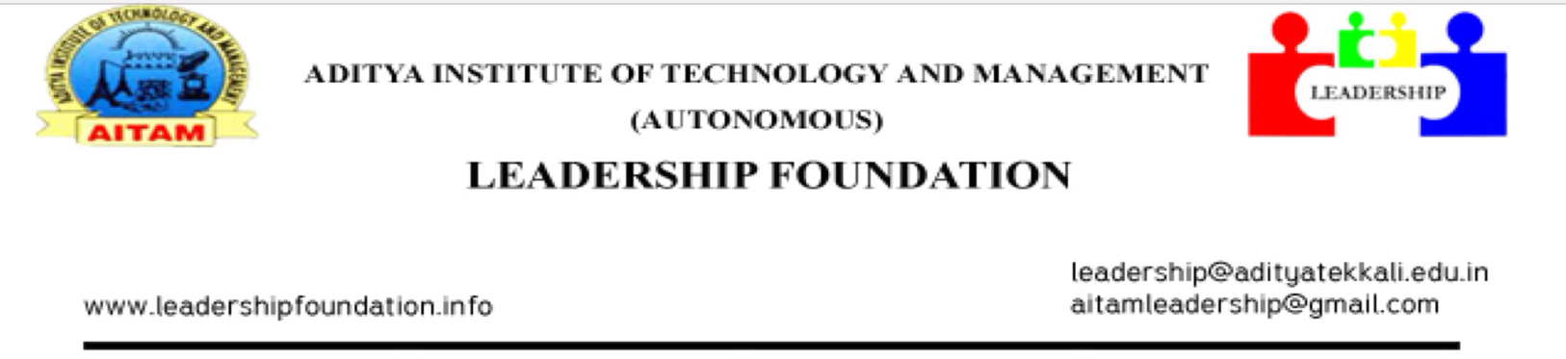

24-09-2015,
Tekkali.

CIRCULAR

All the students who are participating in ROBOTICS WORKSHOP & WEBZION WORKSHOP are requested to attend the workshops on 25th and 26th September 2015 in our college for final output. The students from Palasa, Pathpatnam and nearby areas with no college bus facilities are requested to make own arrangements regarding transport. The travel fare will be re embraced. For Srikakulam college buses are available.

Note: Circulate in I B-Tech Class Rooms
CC to All HOD’s

Sai Vijay.P,
CEO-LEADERSHIP FOUNDATION.

