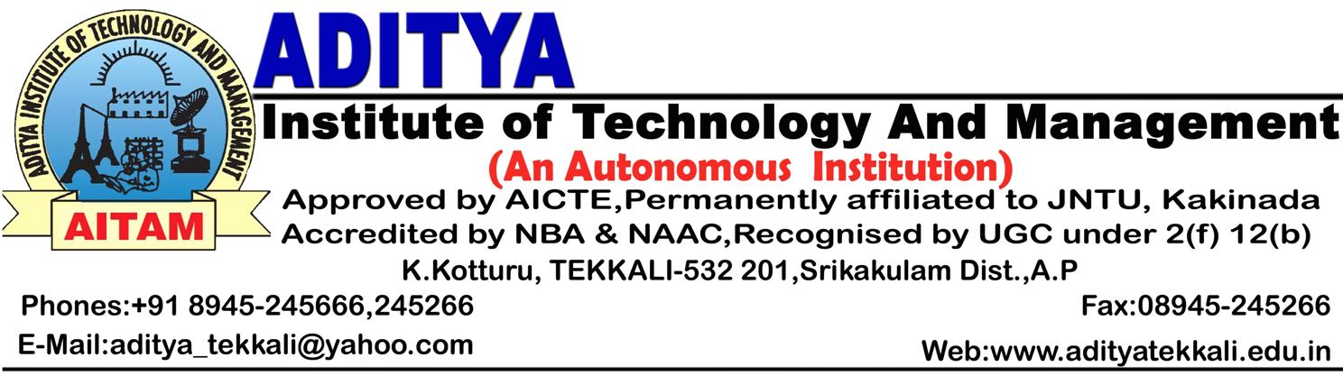 Date: 02.04.2015

SKOCH AWARD-2015
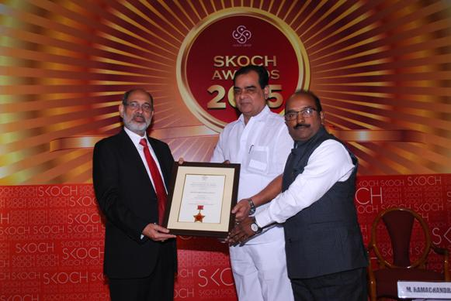
It is glad to inform that Aditya Institute of Technology and Management, K.Kotturu, Tekkali, Srikakulam Dist, (A.P.) has reached another milestone in life – being conferred the Skoch Order-of-Merit Award-2015 as one amongst 200 SMEs out of 2000 nominations sent by various organizations, banks, stock exchanges,etc. in India during the 39th Skoch Summit held on 21st March,2015 at New Delhi. The nomination on behalf of AITAM was sent by the Andhra Bank, Tekkali for the track record of the institute in financial transactions with the Bank. The achievement of winning Skoch Award is also evaluated on the strengths of the institution ethicks and values. The award was received by the Secretary, Sri L.L.Naidu & the Director, Prof.V.V.Nageswara Rao on the hads of the Chief Secretary, Madhya Pradesh on 21st March,2015 at Hotel Le-Meridien, Janpath, New Delh


